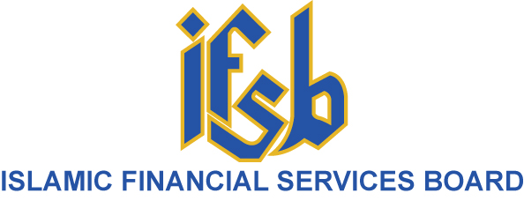

SET B (Market Players and Investors)

SURVEY QUESTIONNAIRE ON
INVESTOR PROTECTION IN ISLAMIC CAPITAL MARKETS

Name of Organisation
Jurisdiction of Operation

Name of Contact Person

Designation

Phone number and Email Address

IFSB SURVEY ON INVESTOR PROTECTION FOR ISLAMIC CAPITAL MARKETS

BACKGROUND AND INSTRUCTIONS
- The Islamic Financial Services Board’s (IFSB) Articles of Agreement set out the objectives of the IFSB. Article 4(a) outlines the objective “to promote the development of a prudent and transparent Islamic financial services industry through introducing new, or adapting existing, international standards consistent with Sharīʿah principles, and recommend these for adoption”. Similarly, Article 4(g) mentions that the IFSB will undertake research into, and publish studies and surveys on, the Islamic financial services industry.

- The Council of the IFSB, in November 2018 approved the commencement of the new project on “Investor Protection in Islamic Capital Markets”. The development of a dedicated Standard on investor protection in Islamic capital markets aims to offer international benchmark guidelines for regulatory and supervisory authorities (RSAs) that address the specificities of Islamic finance in investor protection regimes, complementing the existing international guidelines.

- As part of the Standard development process, the IFSB carries out surveys to collect information and seek the feedback of key stakeholders. The information is utilised through discussion with the established Working Group, and helps better develop the Standard.

- The objective of this survey is to understand the views of relevant stakeholders on the issues in investor protection in their jurisdictions and the pertinent issues that should be covered in a standard on investor protection for Islamic capital markets. The survey takes a fairly broad view of investor protection that covers dispute resolution and redress, as well as product regulation, suitability, disclosure, fair treatment of investors, client agreements, handling of client assets, etc.

- All individual responses to the Survey will be treated as confidential and will be used strictly for developing the revised Standard in conjunction with the Working Group.

- This Survey Questionnaire is for completion by market players and investors.

- To the best of your experience and knowledge, please provide responses that most accurately describe the position or practice of your institution in your jurisdiction in relation to each question. If you consider it useful, please explain your answer in the space provided following the question, where applicable, and describe necessary information which you think is relevant, particularly information that supports your answer. The precision and clarity of your answers is essential in ensuring the accuracy of this Survey.

- The Secretariat would highly appreciate your cooperation to complete the survey questionnaire via online at https://ipicm.questionpro.com on or before 15 March 2019. Ms. Aminath Amany Ahmed (email: aminath.amany@ifsb.org or tel +603-9195 1437) is the project manager for this standard, and she will be pleased to respond to any enquiries you may have.

- Which of the following roles do you play in the Islamic capital markets? Please describe more fully below.
i. | Investor | □
ii. | Issuer | □
iii. | Intermediary (Fund manager, stockbroker, trustee etc.), please specify below | □
iv. | Others, please specify below | □

Please describe here

- Does your business in Islamic capital markets differ in any way from your business in conventional capital markets?
Please describe here

- Which of the following categories do you believe are issues in investor protection in the Islamic Capital Markets? Please describe the issues in more detail below.
i. | Disclosure | □
ii | Product regulation (please specify which type(s) of product) | □
ii. | Conduct of intermediaries (please specify which type of intermediary and conduct) | □
iii. | Redress mechanisms | □
iv. | Investor education | □
v. | Others, please specify below | □

Please describe here

Which of the above issues might usefully be addressed by a Standard on Investor Protection? Where you feel that existing provisions and mechanisms are insufficient to address issues specific to the Islamic capital market, please provide suggestions of how these can be improved to enhance investor protection
Please describe here

- Do you have examples to offer of good industry practice in ensuring investor protection in Islamic capital markets, especially any measures your own institution has taken to protect investors?
Please describe here

****END OF SURVEY****

